Complex Numbers in Quadratic Equations

Solve using the Quadratic Formula

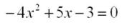
- 2.

3.

Solve by Taking the Square Root

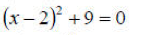
4. 5.

6.
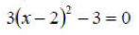

Solve by Completing the Square

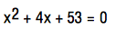
7. 8.

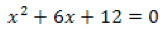
9.

