P- (x – 4)2 = 4(y + 3)

O- (y + 4)2 = 16(x + 3)

N- (y – 3)2 = 4(x + 2)

M- (x + 5)2 = 16(y + 4)

L- (x – 3)2 = 12(y – 2)

K- (y – 2)2 = 12(x – 5)

I- (x + 2)2 = 8(y – 4)

J- (y + 3)2 = 16(x - 2)

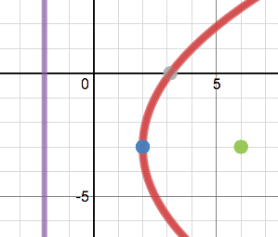

E

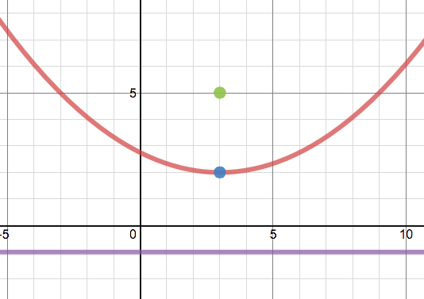

A

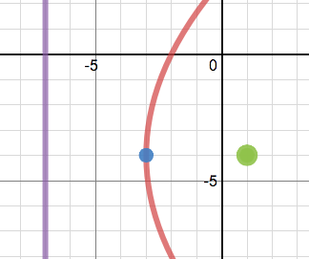

F

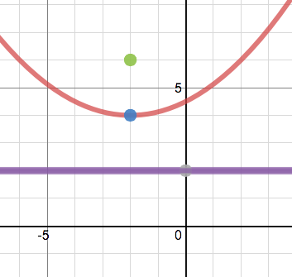

B

PP- Axis of Symmetry: x = 3

QQ- Axis of Symmetry: x = 4

SS- Axis of Symmetry: y = 3

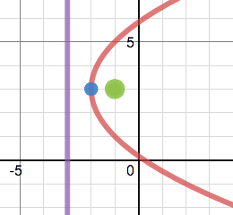

H

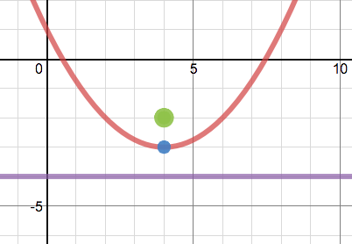

C

RR- Axis of Symmetry: y = 2

TT- Axis of Symmetry: x = -5

UU- Axis of Symmetry: x = -2

VV- Axis of Symmetry: y = -3

OO- Axis of Symmetry: y = -4

RR- Axis of Symmetry: y = 2

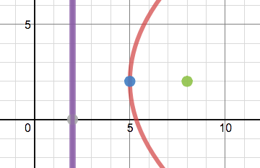

G

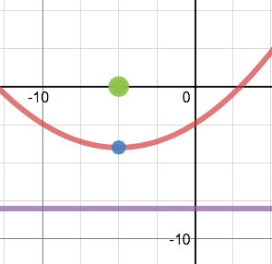

D

CC- Focus: (-1, 3)

Y- Focus: (-5, 0)

Z- Focus: (1, -4)

DD- Focus: (6, -3)

EE- Focus: (-2, 6)

AA- Focus: (4, -2)

BB- Focus: (3, 5)

FF- Focus: (8, 2)

V. Vertex: (4, -3)

Q. Vertex: (5, 2)

GG- Directrix: x = 2

KK- Directrix: x = -7

W. Vertex: (2, -3)

R. Vertex: (-2, 3)

HH- Directrix: y = -8

LL- Directrix: x = -2

X. Vertex: (-3, -4)

S. Vertex: (-5, -4)

II- Directrix: y = 2

MM- Directrix: y = -4

U. Vertex: (3, 2)

T. Vertex: (-2, 4)

JJ- Directrix: y = -1

NN- Directrix: x = -3

**Drag each picture and the matching parts.**