Math 3 Review for Quiz Name_________________________________

YOU MUST SHOW YOUR WORK TO RECEIVE CREDIT!!

Using Completing the Square, write in VERTEX FORM and SOLVE:
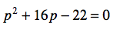
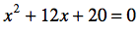
1. 2.

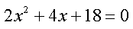
3. 4.

5.

Solve using the Quadratic Formula:
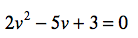
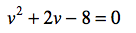
6. 7.

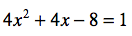
8. 9.

Find the VERTEX, AXIS OF SYMMETRY, and ZEROS :
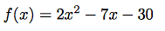
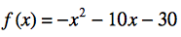
10. 11.

12.

Solve by taking the square root:

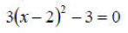
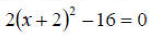
13. 14.

Operations with Complex Numbers

15. (6 – 4i) + (-4 + 7i) 16. (2 + 5i) – (6 – 3i)

17. (1 – 3i)(2 + 4i) 18. (-2 – 2i)(6 – 5i)

Quadratics with Complex Numbers

Quadratic Formula
19.

Taking the square root

20. ${(x + 4)}^{2} + 25= 0$

Completing the square
21.

22. $2x^{2} – 12x$ + 22 = 0

