Math 3 Test 2 Review

Solve for x.

1.
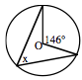

2.
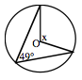

3. Write the ratio:
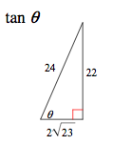

4. Solve for x.
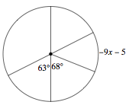

NAME:___________________________________________

5. Solve for the trig function using the unit circle.

cos 90

sin 225

cos -225

sin -240

tan 300

cos -630

sin 990

sec 945

cot 150

csc 60

tan 120

tan 480

6. Solve for x.

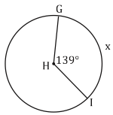

7. Solve for x.

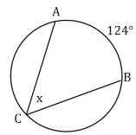

8. Convert from radians to degrees or from degrees to radians.

630º

200º

$$\frac{17π}{3}$$

$$\frac{π}{11}$$

9. Solve for the ?

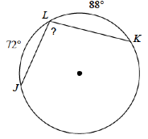

10. Simplify:

$$\frac{3}{2\sqrt{3}}$$

11. Find the arc length AND the area of the shaded region.

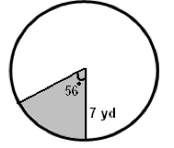

12. Find the arc length and the area of the shaded region.

