Math 3 Review for Quiz Name_________________________________

YOU MUST SHOW YOUR WORK TO RECEIVE CREDIT!!

Using Completing the Square, write in VERTEX FORM and SOLVE:
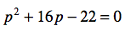
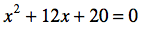
1. 2.

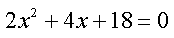
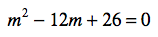
3. 4.

5. 6.

Solve using the Quadratic Formula:
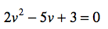
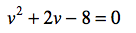
7. 8.

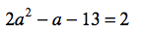
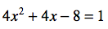
9. 10.

11. 12.

Find the VERTEX, AXIS OF SYMMETRY, and ZEROS :
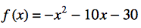
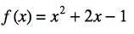
13. 14.

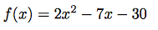
15. 16.

Solve by taking the square root:

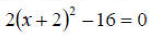
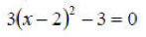
17. 18.

