Math 3 Test 2 Review

Solve for x.

1.

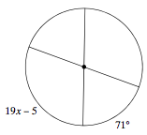

2. Write the ratio for tan $θ$

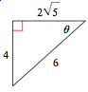

3. Write the ratio for sin $θ$ :
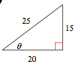

NAME:____________________________________

4. Solve for x.
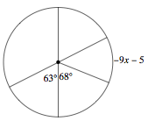

5. Solve for the trig function using the unit circle.

cos 90

sin 225

cos -225

sin -240

tan 300

cos -630

sin 990

tan 120

tan 480

6. Solve for x.

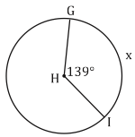

7. Solve for x.

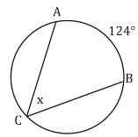

8. Convert from radians to degrees or from degrees to radians.

630º

200º

$$\frac{17π}{3}$$

$$\frac{π}{11}$$
9. Simplify:

$$\frac{2}{\sqrt{5}}$$

10. Simplify:

$$\frac{3}{2\sqrt{3}}$$

11. Find the arc length of the shaded region.

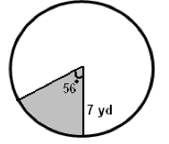

12. Find the arc length of the shaded region.

