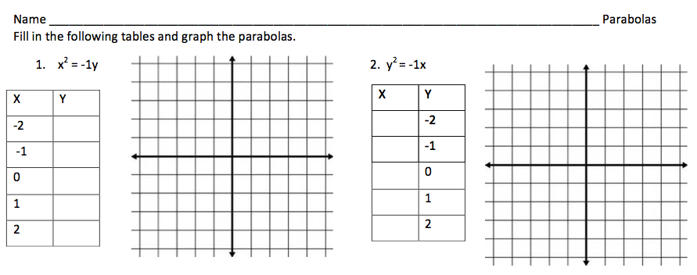

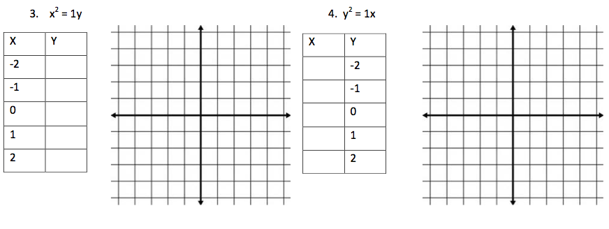

Tell me about the Graph:

On a sheet of paper answer the following questions:

Which way does the graph open?

7. $(y - 3)^{2 }= 2(x + 4)$ 8. $(x + 2)^{2 }= -4(y - 5)$

Use discriminant to decide what type of solutions the following quadratic function has.

1). x² –3x - 4 =0 2). 3x² – 2x + 7 =0

There are __________solutions. There are __________solutions

3). 9x² – 12x +4 =0 4). x² +x +2 =0

There are __________solutions There are __________solutions

