Part 2:
Each answer needs to be typed below and entered in Socrative.

- Using Google or your favorite search engine or previous knowledge, find out what a y-intercept is. Type a sentence explaining and include pictures if you need.

- Using Google or your favorite search engine or previous knowledge, find out how to find a y-intercept both from a graph and an equation. Type a sentence explaining. You may include an example or picture if that is helpful to you.

- What is the y-intercept of y = 3x – 2?

- What is the y-intercept of y = 2x – 3?
x - 2

- Some rational functions have “holes” in their graphs. How would you find out what the “holes” are of a rational function if any? Type a sentence explaining.

When your group gets here stop and check with Mrs. Houck before moving on!
Practice
Find the y-intercepts for the functions.
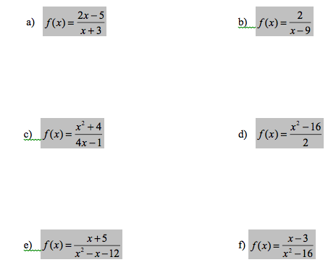

Find the holes of the functions.

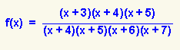
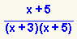
- b)

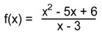
c)

