Table 1- Simplifying Rational Expressions

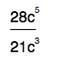

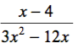

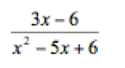

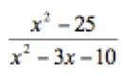

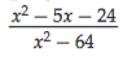

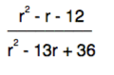

Table 2- Multiplying/Dividing Rational Expressions

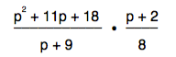

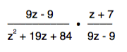

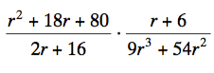

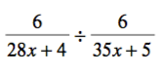

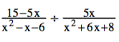

Table 2 – Convert from degrees to radians or radians to degrees.

1. 220º

2. $\frac{16π}{15}$

3. $\frac{-17π}{9}$

4. – 207º

5. 312º

Table 3 – Find the trig values

1. sin 240º

2. tan -135º

3. cos 510º

4. cos 675º

5. sin 630º

6. tan -60º

7. cos -210º

8. sin -750º

HONORS:

- csc 210º

- cot $\frac{7π}{4}$

- sec $\frac{9π}{4}$

Table 4 - Review

- Solve: -3(4x + 3) + 4(6x + 1) = 43

- Solve: 2(4x – 3) – 8 = 4 + 2x

- Simplify: (x – 4)(3x + 2)

- Simplify: (2x + 3)(2x + 5)

- Write a two- column proof:
Given: 2(x + 4) + 2x = 16
Prove: x = 2

Table 5

Name the midline, period, amplitude, and horizontal shift if it applies.

1. y = 3 sin(2x) - 2

2. y = cos(5x + 45) + 1

3. y = 2 sin x - 3

Write the equation with the given information.

4. midline= 2 period= 360 amplitude= 1 horizontal shift= none

5. midline= 1 period= 60 amplitude= 3 horizontal shift= 30º to the right

6. midline= 0 period= 120 amplitude= 2 horizontal shift= 60º to the left

Table 6- Solve by factoring

1.
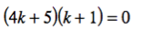

2.
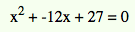

3.
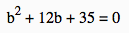

4.
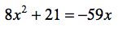

5.
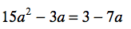

Table 7 - Review

1. Find the arc length of arc HF 2. Find the area of the bold sector.

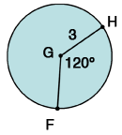
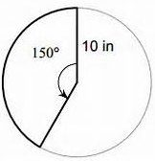

3. Write the equation of the graph: 4. Write the equation of the graph:
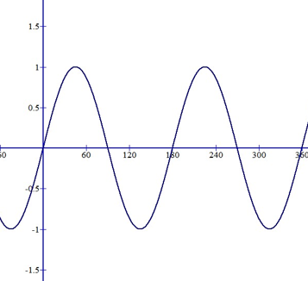

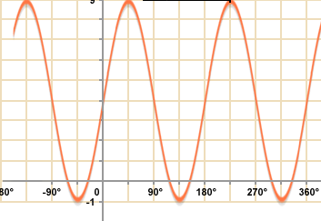

5. Solve for x. 6. Solve for x.

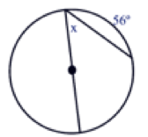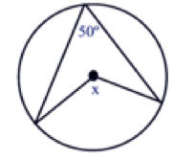

Table 8-

1. Solve for x. 2. Solve for x.

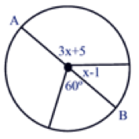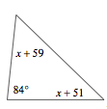

3. Solve for arc FED.

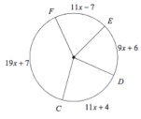

4. Find the length of arc XY. 5. Find the area of the sector.

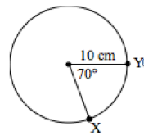

Table 8- Adding/Subtracting Rational Expressions

1.

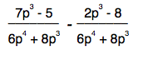

2.

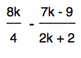

3.

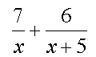

4.
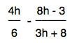

5.

