Table 1- Convert from Radians to Degrees or Degrees to Radians

- 200º

- $\frac{4π}{9}$

- -108º

- $\frac{-5π}{8}$

- 279º

- $\frac{25π}{12}$

Table 2- Write the equation for each graph.

1.
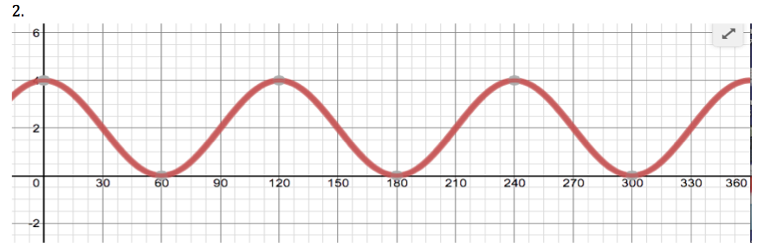

2.

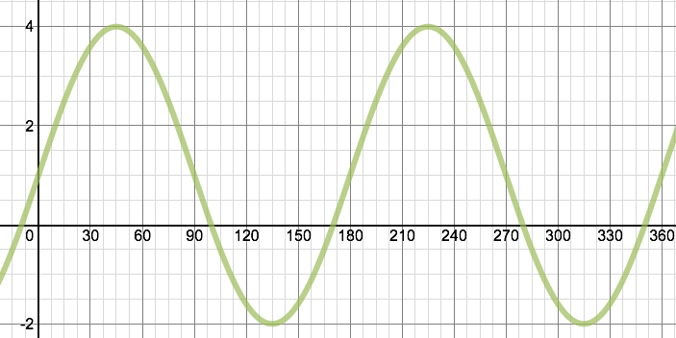

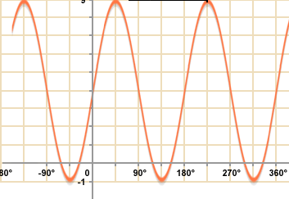

3.

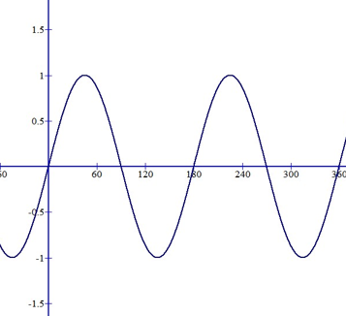

4.

Table 3- Name the midline, amplitude, period, and shift.

- y = cos(3x – 30º) – 2

- y = ½ sin( 2x + 45º) + 3

- y = 3 sin (x)

- y = 2 cos (1/2x + 15º) – 1

- y = sin x + 1

Table 4- Graph each equation.

1. y = 3 sin(2x) -2

2. y = 4 cos x

3. y = - 2 sin x + 3

4. y = sin (3x – 30º) – 1

Table 5- Solve for the trig values.

- sin -150º

- cos 210º

- tan $\frac{7π}{4}$

- sin 870º

- cos $\frac{9π}{4}$

- tan -450º

- sin $\frac{13π}{3}$

- tan 330º

Table 6- Write the equation with the given information.

1. midline: y = -4 amplitude: 2 period: 360

2. midline: y = 1 amplitude: 3 period: 90

3. midline: y = 0 amplitude: 1 period: 120 horizontal shift: 30º to the right

4. midline: y = -2 amplitude: 4 period: 180 horizontal shift: 45º to the left

5. midline: y = 3 amplitude: 1 period: 72 horizontal shift: 90º to the right

6.midline: y = 0 amplitude: 2 period: 6

Table 7- Review

1. Find the measure of < RQP. 2. Find the measure of < YZX.
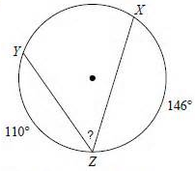
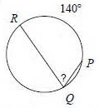

3. Find the measure of the arc AC. 4. Find the area of the sector.
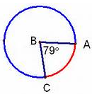
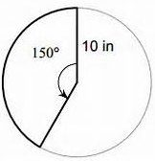

5. Find the arc length of arc FH.

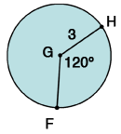

Table 8- Review

- Solve the equation: -3(x + 2) + 6x = 2x + 3

- Solve the equation: 2(4x + 3) + 5 = 3(x + 2)

3. Solve for x.
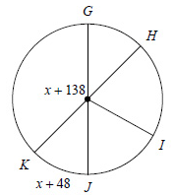

- Using the picture in #3, solve for the measure of arc JKH.

5. Solve for arc AC.
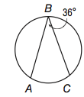

6. Solve for the missing angles.
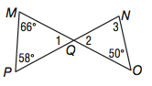

Table 5- Solve for the trig values.

- sin -150º

- csc 210º

- cot $\frac{7π}{4}$

- sin 870º

- sec $\frac{9π}{4}$

- tan -450º

- sin $\frac{13π}{3}$

- tan 330º

