Name _________________________________________________________________________________ Trig Graph Transformations
- Go to 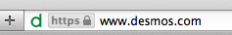 and click .

- In the box type 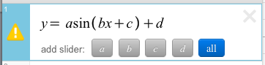 and click “all” to add sliders for a, b, c, and d.

We are going to start of by finding how the value of “a” effects a sine graph.

Move the slider for “a” back and forth and watch how the graph changes.

- How does the value of “a” effect the graph? Does it change the amplitude, midline, or period?

- How does the sign of “a” effect the graph?

We are now going to see how the value of “b” effects a sine graph.

Put the slider for “a” back at 1. Move the slider for “b” back and forth and watch how the graph changes.

- How does the value of “b” effect the graph? Does it change the amplitude, midline, or period?

- How does the sign of “b” effect the graph?

We are now going to see how the value of “c” effects a sine graph.

Put the slider for “b” back at 1. Move the slider for “c” back and forth and watch how the graph changes.

- How does the value of “c” effect the graph?

We are now going to see how the value of “d” effects a sine graph.

Put the slider for “c” back at 1. Move the slider for “d” back and forth and watch how the graph changes.

- How does the value of “d” effect the graph? Does it change the amplitude, midline or period?

